PIROGUE

(PRG, PRK, BRG, BRK: consonant superstructure of connected words)

Grimm’s law and Vernor’s Law explained:

BH DH GH

B D G

P T K

F TH V

Over time, the Consonants listed above, when used in the oral tradition (some suspect due to lazy tongues), eventually change from Bh to B to P to F, and from DH to D to T to TH, and also from GH to G to K to V. These laws seem to be universal, regardless of cultures, in all languages and alphabets, for these are the tonal sounds that people articulate. The words that have similar meanings across cultures and languages appear to have these same consonant superstructures and connections and can be seen as similarly rooted in ancient words and meanings.

(To test these sounds for yourselves, say the ‘sounds” for T and D…….. ‘Tah”…. “Dah,” and notice how your mouth and tongue and teeth and lips make each sound and how similarly they are placed and produced in your mouth. Do the same with G and K ………….”Gah”… “Kah,’ and also do the same with P and B………. ”Pah’….. “Bah.”

These consonant pairs are what are known as linguistic equivalents. And words with these same consonant superstructures are viewed as very similar in meaning and/or origin.

From A Concise Etymological Dictionary of the English Language by Walter Skeat:

“Pirogue”: a sort of canoe. (French—West Indian). Defoe has periagua (peri-agua, meaning “through the water” in Latin) – French, pirogua (Spanish, piragua). From the native West Indian Name; said to be Caribbean.

From The Origin of Language by Arnold Wadler:

American Indian--------------Pirogue (boat)

Malayan--------------------------Perahu (boat)

Danish----------------------------Faerge (ferry)
French----------------------------Fargue (boat)
Munda----------------------------Borga (raft)
Samoyede-----------------------Worga (boat)

From Basque/English Dictionary by Gorka Aulestia and Linda White:

Piragua ------- Canoe

From Italian/English English Italian Dictionary by J. E. Wessely:

Barca----------Boat

From English/Spanish Spanish/English by Arturo Cuyas:

Barco, Barca-----------Boat

From Hebrew/English English/Hebrew Dictionary by Hayam Baltsan:

Baruch-------------------Blessed

Parokhet-----------------The Curtain over the doors to the Holy Torah Ark [Bark] (in a synagogue).

From A Dictionary of the Ojibway Language by Frederick Baraga:

Bakobina------------- (Ba[r]k-- [boat] –kob-- [cove]—in-- a)
“I launch or put him in the water.”

From Latin/English English/Latin Dictionary by D. P. Simpson:

Pirata-----------------Pirate

From Pocket Oxford Irish Dictionary:

Farraige-------------Sea

From Welsh/English English/Welsh Dictionary:

Canwe-------------------Temple

From Arabic/Persian:

Khyakh (pronounced ghayak)-----------Boat

Baracka---------------------------------------Boat, Ship

From Random House Webster’s College Dictionary:

Piranha -----------------------South American Fish

Piroshki ----------------------Small turnovers with a filling, as
of meat and vegetables

From Webster’s Third International Dictionary Unabridged:

Baraka---------------a blessing that is regarded in various
Eastern Religions as an indwelling
spiritual force and divine gift.

Barat-----------------a violent squall from the Northwest that
occurs in Menando Bay Indonesia.

Barcelona--------- City in Spain on the coast of the
Mediterranean.

Barchan------------a moving sand dune shaped like a
crescent.

Bargain------------an agreement, to trade.

Barge---------------a sailing vessel.

Barghan-----------Horse collar.

Barghest----------A Ghost or Goblin.

Bark-----------------Outside wood, covering a tree, a small
sailing ship. (from which we get
embargo, embark, disembark,
embarkation, etc.)

Barouche----------A four wheeled shallow carriage.

Barque--------------Bark, Boat

Barrock-------------Hut used for temporary shelter.

Barracoon---------An enclosure or barrack formerly used
for temporary confinement.

Barracouta--------Large marine fish

Barrage------------An artificial dam placed in a river or
water-course to increase depth of water.

Barricade----------An obstruction or rampart.

Barraco------------Small cask, keg.

Barragudo---------Belly, Barrel.

Berakah-------------Benediction, Blessing.

Berg------------------Iceberg, Mountain.

Bergan--------------a rucksack supported by a wooden
frame and having a belt to fasten
around the waist.

Berycidae----------A family of fish.

Birch----------------Type of tree.

Birgus--------------The genus containing the purse crab.

Birk-----------------Birch.

Borachio----------Drunkard.

Borak--------------Cabbage.

Borough----------A medieval fortified group of houses.

Bourg--------------Fortified place.

Bourgeois--------A middleclass person.

Bourka-------------Burka, hat.

Bourock-----------Crude Hat.

Braccae------------Woolen pants.

Brace---------------To encircle, surround.

Brack---------------Swampy Ground, salt water.

Bracket------------To place within.

Brake---------------Cage, Trap, Snare.

Breach-------------An opening or gap in a wall.
Break---------------A bodiless carriage or frame.

Breech-------------Short trousers.

Brig----------------A massive square rigged vessel.
(Brigade, brigadier).

Brigand----------One who lives to plunder.

Brique------------Intrigue.

Broach-----------To break to the surface from below as of
a whale or a torpedo, to veer or yaw in a
following sea.

Brock-------------A luminous ring around the Moon, one of
the prehistoric circular towers found on
Orkney Islands consisting of double
walls enclosing small apartments about
a central court.

Brook-------------Stream.

Bruik--------------Brook.

Burg---------------An Ancient or Medieval fortress or walled
town (Burgage).

Burgao-----------A common top shell [mollusk] whose
flesh is esteemed as food and whose
shell is used in making buttons.

Burgee------------Master of the house.

Burger-------------A flat cake of ground chopped meat
served between 2 slices of bread.

Burgh--------------City Town (Burgher).

Burka--------------A Coarse Cloak worn in Russia, a loose
enveloping garment.

Burke--------------To bypass, avoid.

Burga--------------Burka.

Burrough---------Burough, City.

Farci---------------A stuffed dish (as a roast or fowl).

Farouche---------Lacking Social Graces.

Farrago-----------Mixed fodder for cattle, mash, mixture.

Farruca-----------A Spanish Gypsy Dance having sudden
changes in Mood and Tempo.

Feraghan---------Small Persian rug of cotton, usually a
web and a fringed end, a deep blue or
rose field with an overall berati
sometimes guli binnari design and a
main border with a turtle* design and
being prized if antique.

Feringhee--------A Eurasian of Portuguese-Indian Blood.

Ferriage----------Transporting by Ferry.

Ferry--------------To Carry, convey in a boat.
Fierce-------------Marked by grim, pugnacious, or wild
hostility, savagely intractable, barbarous.

Firca---------------Tribe, Group, community.

Force--------------Strength or energy of an exceptional
degree.

Forage------------To make a search, rummage.

Foreign-----------Situated outside a place or country, alien
in character.

Forge--------------To move forward or ahead steadily but
slowly or gradually (as in a ship).

Forgo--------------Leave, forsake, to depart from, quit.

Paraceto Bark---Dried bark of a Bolivian Tree.

Parage-------------Equality among persons.

Paragon-----------Model of excellence or perfection.

Paraguay----------Country on South America.

Parakeet------------Bird.

Parakinesia--------Disorder of Motor Functions.

Pergana-------------A group of towns in India constituting
an administrative subdivision of the
Zillah.

Parget----------------To administer ornamental plasterwork.
Parging--------------A thin coat of plaster, or plaster coat
to smooth or waterproof.

Pargo-----------------Any of various fishes of the family
Sparidae, any of various Snappers.

Park-------------------Enclosure for animals, an enclosure of
ground, stocked with beasts of the
chase, used as a game preserve.

Parka-----------------Skin, Outer garment.

Parkin----------------A cake originally of oatmeal, butter,
and molasses, now leavened with
baking powder and spiced with ginger,
and especially popular in Scotland.

Paroqueth----------A curtain of richly ornamental material
hung before the Holy Ark in a
Synagogue as a reminder of the
Curtain used to screen the Holy of
Holies in the Tabernacle and the
Temple (Paroket).

Parochial-----------Confined or restricted as if within the
borders of the Parish.

Paroquet------------Parrakeet.

Parquet--------------An enclosure for animals.

Parrakeet-----------Any of a number of small parrots.

Parrock-------------Enclosure.

Pauroque----------Cuiejo, a tropical American Nighthawk.

Perca----------------The type genus of Percidae, formerly
including numerous perches [fish].

Percale-------------A firm smooth cotton cloth, closely
Woven.

Perch---------------Fish, to come to rest, often
precariously, or uneasily.

Pergola------------Projecting roof, an open arch [ark] or
covering for a walk, arbor, trellis.

Pericon------------A group Circle Dance of the Uruguayan
and Argentine Pampas.

Pericope----------A selection or extract from a book,
especially a selection from the Bible, to
be read in church or as a text for a
sermon.

Pericu--------------An Indian People of Southern California,
Mexico.

Perigee-------------The point in the orbit of a satellite as it
is nearest the center of that which it is
orbiting.

Perrique------------Otter.

Perk------------------Perch; to lift as in the spirits of.

Perruque-----------Peruke, one of several wigs worn
between the 17th and 19th centuries.
Perruche-----------A kind of parrot.

Perugian-----------A native of Perugia, Italy.

Peruke--------------Wig.

Pier-------------------A structure built out into the water on
piles for a landing place for boats.

Piragua-------------A canoe made out of a hollowed tree
Trunk.

Pirarucu------------A large scaled osteo glossed fish.

Pirca-----------------A crude dry Masonry wall (Quechua).

Piririqua------------A large American Cuckoo.

Pirogen-------------Small filled Pastry, Yiddish, Russian.

Pirogue-------------(also piroque) A dug out canoe
(Caribbean).

Piroshki-------------(also Pirojki) Small pocket of pastry,
small pastry turnovers filled with
savory filling.

Porch----------------A covered entrance to a building, side
Chapel.

Porge----------------To make a slaughtered animal
ceremonially clean, according to
Jewish Ritual.

Porgy----------------A Sparid Food fish that inhabits the
Mediterranean and Atlantic Coasts of
Europe and America.

Pork------------------The Flesh or Salted Flesh of swine.

Porridge------------A soft food made from boiling grains.

Prague--------------Capital City of Czechoslovakia.

Preach--------------To proclaim publicly, praise, to set
forth in a sermon.

Preke----------------Octopus.

Prick-----------------A small or shallow hole made by a
sharp instrument.

Prig-------------------One Self-sufficient in virtue, culture, or
propriety often in a pointed manner or
to an obnoxious degree.

Prog-------------------To poke or search about especially in
order to steal, beg, or chance upon
something profitable (forage).

The above words in italics are variants of the consonant superstructure of the letters PRG, PRK, BRG, BRK, following Grimm’s law and Vernor’s law.

It appears that the word “PIROGUE,” or variants thereof, can be found on both sides of the Atlantic basin, from Iceland, the British Isles, Western and Eastern Europe, the Mediterranean, Africa, Brazil, Columbia, Venezuela, all of the Caribbean, North America and Canada.
There may be no accepted Academic proof that there ever was a Continent/Civilization in the middle of the Atlantic Ocean that went down in a series of violent volcanic eruptions somewhere around 9600 BC (or approximately 11,000+ years ago) causing a massive world wide flood from which Noah and family escaped on the Ark…….However, even with no definitive physical proof, as oceanographers have been unable to uncover definitive evidence of a civilization on the bottom of the Atlantic floor that’s about 11,000 years old buried under tons of volcanic ash, lava, and sludge, and is indicative of a race of people of distinguished advancement, we have peoples all over the Atlantic basin on all shores who share extensive language fragments, customs, religious symbols, dances, art works, legends, stories, etc, that indicate an ancient link of tremendous proportions.

In many Eastern European households today there is an unusual ceremonial traditional food called “Pieroguies” that may be a significant linchpin to an amazing Atlantean connection. The word Pieroguie (food) and the word Pirogue (boat) are different in letters, but virtually identical in sound.

The formation of and the making of pieroguies are what are perhaps so fascinating: Pieroguies are pastry products that require a bottom boat shaped curved shell that is then filled with various forms of ingredients (potatoes, onions, meats, fruits, etc) and then is covered by a top shell of similar shape to the bottom shell. The sides of the pieroguies are then perfectly sealed to completely enclose the contents so that they cannot spill out [If this isn’t a perfect description of the House Boat, ARK, with a sealed top that was Noah’s, I don’t know what!!!]. Hundreds are made in the same shape and size (maybe 2 inches by 3 inches) and a very large pot of water is placed on a stove and the water is heated to boiling. When the cauldron of boiling water (like a turbulent ocean) is prepared, all of the pieroguies are dumped into the water. When the pieroguies, after a few minutes, float to the surface of the water they are removed from the boiling water and are ready to eat (unless you also want to fry them [with onions]).

The entire method of preparing pierogueis today exactly replicates and represents the building of boats (like Noah’s Ark [BARK]) in their preparation for the impending eruptions and explosions that Atlantean citizens prepared for when they anticipated and knew that their homeland was soon to be doomed. It is perhaps astounding that Eastern Europeans still possess a sacred food that is a perfect ritual and remembrance of the process that their ancient ancestors developed and passed down for 11,000 years, and it is positively unusual and remarkable and miraculous. The names for this “food” and for those ‘boats” are still identical. The process of making them, including the boiling volcanic water, is astounding. The word for ‘boat” (PIROGUE) and all of its variants found all around the Atlantic basin indicate that the Atlantic basin peoples all have had that language connection with the word “boat” from their ancestors who survived the flood and ended up on solid ground anywhere and everywhere else in the Atlantic basin. Noah quite clearly did not possess the only boat. There must have been hundreds, if not thousands…….

Those of you who celebrate the use of pieroguies as ceremonial sacred food are in fact celebrating the voyages of Noah and/or any of the rest of the 10 lost tribes of Israelites who left the Old Lost Sunken Red Land for unknown destinations.

The ancient word for “People” in Hebrew is Anishe-em.”

The ancient word for “People” in Ojibway is “Anishinabe.”

But there’s more!!!!!

The Ojibway (Chipewa) peoples consider themselves descendants of those who escaped their lost homeland (The Old Sunken Red Land), and they still consider themselves as part of the Turtle Clan. If you go to any of the Ojibway web sites their Turtle Clan emblem is first and foremost a part of the site. Atlantis was called Turtle Island as its volcanic and earthquake movements made it appear to be a moving land at sea all the time, like a live animal in the water.

Plato’s account of Atlantis comes into play here:

“…Poseidon, the god of the sea, receiving for his lot the island of Atlantis…He also begat and brought up five pairs of male children, dividing the island of Atlantis into ten portions [ten lost tribes]; he gave to his first born of the eldest pair, his mother’s dwelling and the surrounding allotment, which was the largest and best, and made him king over the rest; the others he made princes, and gave them rule over many men and a large territory. He named them all. The eldest who was king, he named Atlas, and from him the whole island and the ocean received its name. To his twin brother, who was born after him, and received as his lot the extremity of the island toward the Pillars of Hercules, he called Gades and the region is still called Gades, which in the Hellenic language is Eumelus, and in the language of the land which was named after him is Gadeirus. Of the second pair of twins he called one Ampheres and the other Euaemon. To the third pair of twins he gave the name Mneseus to the elder and Autochthon to the one who followed him. Of the fourth pair, he called the elder Elasippus and the younger Mestor. And of the fifth pair he gave to the elder the name of Azaes and to the younger Diaprepes.”

The above description indicates that there were five sets of twins who ruled Atlantis, all descendents of Poseidon.

In Cleveland Ohio there is a very large and ancient and beautiful rendition of a wall hanging tapestry (it is a copy, exact replica, of a very ancient tapestry that was behind the Ark in a temple in Eastern Europe) behind the Ark, Torah, and Altar in Temple Israel Ner Tamid off of Lander Road (Maple Heights) in the east side of Cleveland. At the very top and center of this tapestry are two hands in an unusual formation. I asked the Rabbi, Fred Eisenberg, what those two hands symbolized and he told me it was a very ancient Hebrew Blessing. If you take both of your hands and form them into the Star Trek “Live long and prosper” designation and then place both hands together so that the thumbs are side by side, you then have what was at the top of the Tapestry with both hands pointed upwards with all ten fingers, all ten of them, separated in pairs of five sets of two…………….. Do you now see the connection? This is a perfect representation not only of the five sets of twins who ruled Atlantis, but the hands together also form the body of a Turtle………….

There are representations of Turtles all around the world in various cultures and religions as being the original foundation of the world. There are still Temples of the Turtle in the Yucatan and in the Azores.

In The Chinese Book of Changes (The Richard Wilhelm Translation, Bollingen Series, Princeton University Press) there is a description of the best good luck bestowed upon the Reader of the Yarrow Stalks, “Someone does indeed increase him. Ten pairs of tortoises cannot oppose it. Supreme good fortune.” This is a statement like “Better than double of nothing.”
The I Ching was brought out of the West [from Atlantis] at the time of the great flood by the first Emperor of China, Emperor Fu (Kung Fu Tze—or Confucius [the first of many named Confucius]).

Another interesting connection is that all pictures of Poseidon could be representations of Vishnu, as they are nearly identical in all of their display and symbolism.

Indeed we are all ONE, as can be seen by just a few of these references here………..and there are so many more connections than what is put forth here!!!

Blessings and Namaste!!!!

TG

- *The turtle connection with the word Feraghan may now seem obvious!!!
Just discovered:

Bakkah------------------ (also transliterated Baca, Baka,
'Bakke',Bakah, Bakka, Becca, Bekka, etc.) is the ancient name for the site of Mecca.[1][3][6][7] An Arabic language word, its etymology, like that of Mecca, is obscure.[8] http://en.wikipedia.org/wiki/Bakkah

Bakkah--
One meaning ascribed to it is "narrow," seen as descriptive of the area in which the valley of the holy places and the city of Mecca are located, pressed in upon as they are by mountains.[3] Widely believed to be a synonym for Mecca, it is said to be more specifically the early name for the valley located therein, while Muslim scholars generally use it to refer to the sacred area of the city that immediately surrounds and includes the Kaaba.[2][9][10] http://en.wikipedia.org/wiki/Bakkah

The form Bakkah is used for the name Mecca in the Quran in 3:96, while the form Mecca is used in 48:24.[8][11] In South Arabic, the language in use in the southern portion of the Arabian Peninsula at the time of Muhammad, the b and m were interchangeable.[11] The Quranic passage using the form Bakkah says: "The first sanctuary appointed for mankind was that at Bakkah, a blessed place, a guidance for the peoples. The original Hebrew language phrase for the Valley of Baca is emeq ha-Baka.[15][16][17] It can also be translated as "Valley of the Balsam Tree"[Kon Kiti--The balsa wood raft Kon-Tiki was built as a copy of a prehistoric South American vessel. Constructed of nine balsa logs, a crew of six men sailed the raft from Callao in Peru on 28th of April 1947 and landed on the island of Raroia in Polynesia after 101 days. This successful voyage of c.4300 miles proved that the islands in Polynesia were within the range of this type of prehistoric South American vessel…….. from pre-Incan times mastered the art of ship building using balsa wood ... Life in Ecuador] http://en.wikipedia.org/wiki/Kon-Tiki
or "Valley of the Weeper".[15][16] This otherwise unidentified valley has been connected to Bakkah by Islamic writers. http://en.wikipedia.org/wiki/Bakkah

Another connection: Left: At first glimpse, it just looks like a rocky, typical landscape but closer study reveals evidence of Early Man. Gray Mountain outside of Baku.

Say the word "archaeology" in Azerbaijan today, and most people automatically think of the prehistoric Gobustan reserve. Located about 54 km southwest of Baku, this area and its ancient rock carvings provide striking evidence of how early humans interacted with their environment, perhaps even as far back as 5,000 to 10,000 years ago. [Baku is in fact just a hop, skip, and a jump from Mt. Ararat]

Visitors to Gobustan marvel at the site's unique rock carvings and petroglyphs that provide a snapshot of prehistoric life and culture, with images of reed boats, women dancing and hunters chasing their prey. Here are wonderful depictions of wildlife, including many species of antelope and wild bulls that are now extinct. These petroglyphs show that prehistoric humans had great ingenuity and a certain level of sophistication - not to mention an amazing ability to survive amidst primitive conditions. The late Norwegian anthropologist Thor Heyerdahl (19142002) was fascinated by the carvings at Gobustan, especially the images of reed boats. Heyerdahl himself was famous for building boats of balsa wood, papyrus and marsh reeds, and then taking them "out for a spin" on long trans-oceanic expeditions. He made four such journeys demonstrating that early humans were equipped to travel great distances and interact with people in distant lands. (See Thor Heyerdahl's account of his Tigris expedition in this issue.) http://www.azer.com/aiweb/categories/magazine/ai111_folder/111_articles/111_cart_ruts.html

Boat in Chinese:

The term ultimately stems from the Chinese chuán (船, "boat; ship"), also based on and pronounced as [dzuːŋ] (Pe̍h-ōe-jī: chûn) in the Min Nan variant of Chinese, or zhōu (舟), the old word for a sailing vessel.^{[citation needed]} It entered the English language in the 17th century through the Portuguese junco from the Javanese jong.^{[3][4]} The modern Standard Chinese word for an ocean-going wooden cargo vessel is cáo (艚).^{[5]}
^{(from Wikipedia)} http://en.wikipedia.org/wiki/Junk_(ship)

Perahu - from Tamil Padagu meaning Boat http://www.translationdirectory.com/glossaries/glossary241.php
Parisal, sometimes spelt as parical - Tamil^{[5]} http://en.wikipedia.org/wiki/Indian_coracles
A pirogue (or piragua or piraga) can be one of several kinds of small boats. One kind is associated particularly with the Cajuns of the Louisiana marsh. The early Cajun pirogues were cypress dugouts but today they are usually flat-bottomed boats. Pirogues are not usually intended for overnight travel but are light and small enough to be easily taken onto land. The design also allows the pirogue to move through the very shallow water of marshes and be easily turned over to drain any water that may get into the boat. A pirogue has "hard chines" which means that instead of a smooth curve from the gunwales to the keel, there is often a flat bottom which meets the plane of the side. The pirogue is usually propelled by paddles that have one blade (as opposed to a kayak paddle, which has two). It can also be punted with a push pole in shallow water. Small sails can also be employed. Outboard motors are increasingly being used in many regions. In West Africa they were used as traditional fishing boats.^{[1]} http://en.wikipedia.org/wiki/Pirogue
A pirogue is a small, flat-bottomed boat of a design associated particularly with West African fishermen^{[29]} and the Cajuns of the Louisiana marsh. These are usually dugouts, and are light and small enough to be easily taken onto land. The design allows the pirogue to move through the very shallow water of marshes and be easily turned over to drain any water that may get into the boat. The pirogue is usually propelled by paddles with one blade. It can also be punted with a push pole in shallow water. Small sails can also be used. Outboard motors are increasingly being used in many regions.
African, Tsonga -- Barika ~ Boat ^ Noun Tsonga is spoken throughout Southern Africa by the Shangaan-Tsonga culture, but is concentrated in Zimbabwe, Mozambique, Swaziland and South Africa. Tsonga is a part of Bantu branch of the Niger-Congo languages. http://en.wikipedia.org/wiki/Traditional_fishing_boat

So many old and ancient cultures utilize symbols that involve the star and the crescent. So many of these are represented in such a way that they may be looked at as boats:

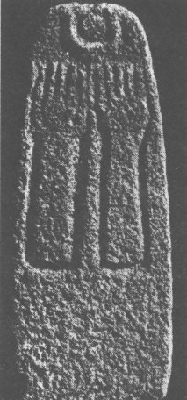

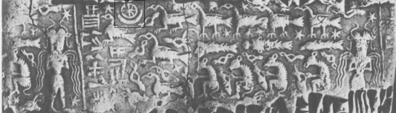

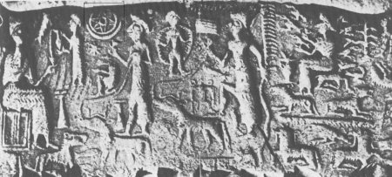

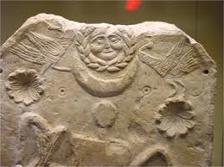

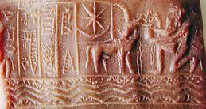

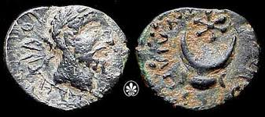

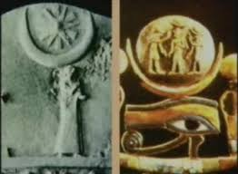
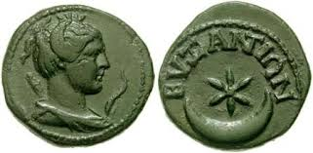
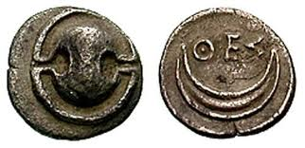
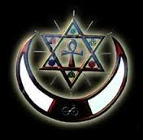
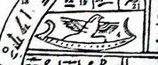
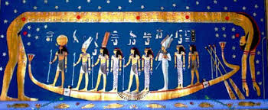
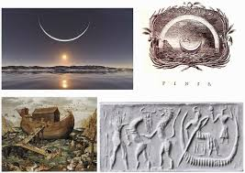
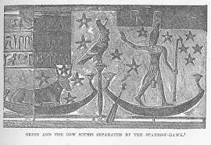
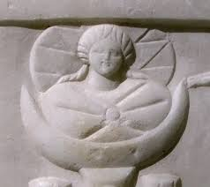
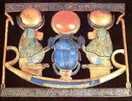
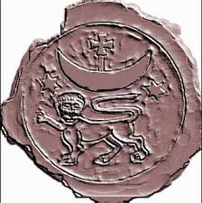
All of the above pictures come from a website that is depicting examples of the star and crescent:
https://www.google.com/search?biw=1518&bih=691&tbm=isch&source=univ&sa=X&ei=zzZ5VNjMIceagwTgoYOQDw&ved=0CB0QsAQ&q=pictures%20of%20ancient%20depictions%20of%20the%20star%20and%20crescent

