I Think I Was Young Once
By T. W. Gilbert

I Think I Was Young
Once
I sit and feel my aching bones and won-
der how they aged. My hands look
like my grand-
father’s, it’s not that I’m outraged.
The sun
which looks the same as always
seems to stand

with time, that ticking, tocking wealth
of nerves
that treats age like a crime. I think I’m
still
fifteen, but old time’s laughter just
observes,
my body’s frailty, front to back; that
skill

of pill preserves. I cannot fool myself
for long, my time is waning fast. I
think
I’m like a ragged book upon time’s
shelf
that’s passed. I write to keep a
journal link-

ing all that I’ve seen here. So while

death’s near
I hope and pray it’s maybe not this
year.
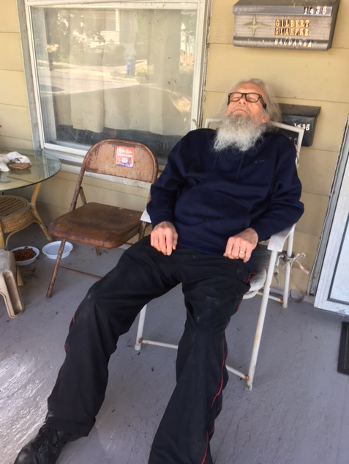
I don’t remember much about my
past
and early youth. It seems what I
recall
forever’s lost in hazy truth. The last
thing older brother claimed was not
forestall-

ing death. Though one year old,
remembered still,
I cried with every breath. The
vomit smell
screamed through the air. His
drowning shared a chill.
Alone in crib and empty room, my
hell

was graced with skill. My family, so
lost
in grief, had plum forgotten me.
The toll
of death from one so young had
surely cost
a fee: dysfunction paved an endless
goal,

a template we all wore; we did
ignore
what happened there, what ripped
us to the core.

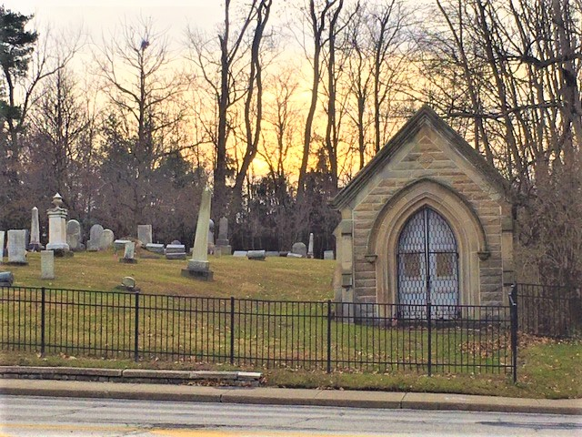

The dead the dead have buried
though there’s more
that we have tombed: all feelings
and ripped hearts
and minds; our health was always
doomed. Ignor-
ing what we lived through has fixed
all our starts

with stops. Each elephant in every
room
rejoices where it flops. Dysfunction
kills
all moods and cares and
masterminds our doom.
Regurgitated blame is shared with
skills

that foster gloom. Pretending we’re
O.K.
is always faking who we are. His
pass-
ing was the breaking point that
helped display
this scar, a place in life where
broken glass

seems normal under foot, where
gracious soot
and weathered dust keep silent
thoughts well put.

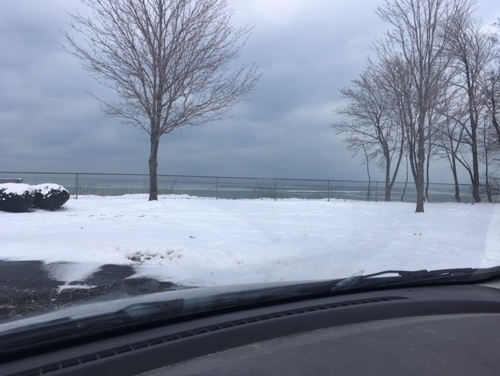

The pain that is our bones is like the hurt
that is our skin. We grieve through
smiling laugh-
ter, as we piece where to begin. The
dirt
we never can remove makes
searching half-

way done. Our therapists consider
cheer,
but gray skies bury sun. We long for
times
we’ve never known, for times that
may be clear.
But agony we know too well keeps
crimes

of loss so near. Each step each day
is bur-
densome, but life goes on we’re told.
We can-
not stop to figure out which dreams
deter
what’s cold. We wonder if there is
some ran-

som, we could pay a court, to lend
support
to our failed quests and end this
Hellish sport.

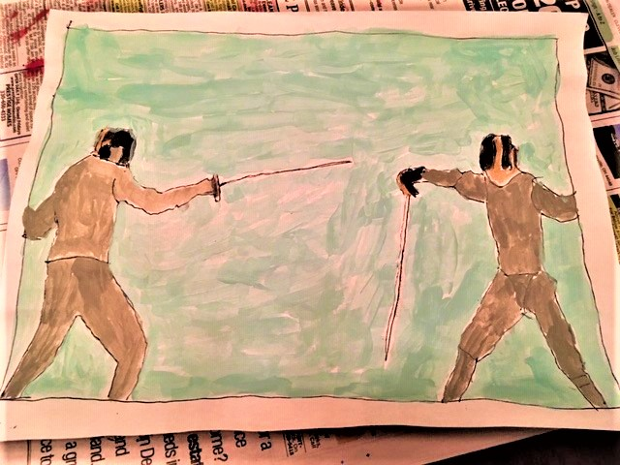

With no directions to this box, no lid,
no keys, no clues. We don’t know if
we’re in
or out, or if life’s blown a fuse. What’s
hid
are timeless questions just to help us
win

then lose. We only know the
vacancy,
of all the mess we choose. There are
so man-
y in this boat, just wishing to be free,
though wondering how long this trip,
and when

we’ll dock at sea. Horizons have no
land-
ing spots, no mimicry of rest. The
waves
are laughing at our sides, the Fates
have planned
this test: like Plato we are lost in
caves,

where shadows dance and dream.
Realities seem
far from hope, and hope just makes us scream.

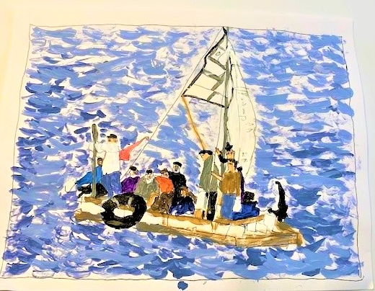

Like loss and grief this healing is a
nev-
er ending space, in which we live and
strive
and grow; it’s weirdness we all face. The clev-
erness of stepping stones, so slippery, live,

and crazed, on which we balance what we are,
while trudging hallways mazed, are worth the ef-
forts we put forth, to reach that inner star.
Our loser egos ruling here seem deaf

to what’s afar, what’s hidden deep within
our hearts, that light divine and whole. It’s there
we strive to just become what’s part akin
God’s Soul. Returning to our Source, that ver-

y stillness, being free, where doorless key
that’s love and light is right for you and me.

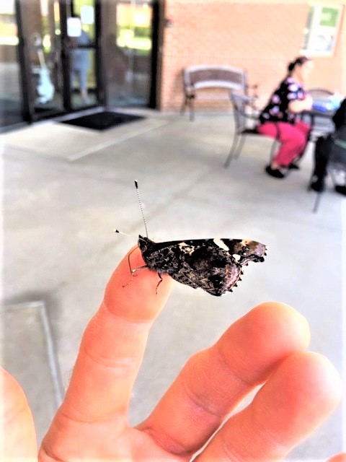

And life goes on, but ends for those,
who slip
into beyond. They’re still around, not vis-
ible, but energy’s their bond. The rip
of death seems so absurd. It’s not what is-

n’t real, just breaks lifetimes of conversa-
tion, ends how sharings feel. We can’t go back,
but memories are what come into play.
We still converse, with no reply, attack-

ing what we say. Death stands us up, and sits
us down, and walks with us each day. We’re lost
with loss, yet time goes on, it never fits
this gray, this mix of black and white, the cost

of life, this time around. And though we’re bound
to friendships gone, there’s loss that we have found.

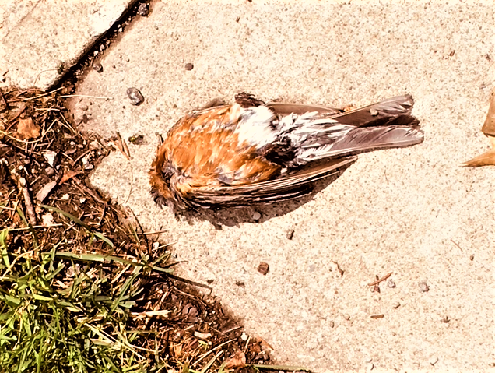

What crime did we commit so young that served
us into Hell? What karma that we don’t
remember cast this awful spell? Deserved
or not what Godly love makes scars that won’t

undo? The constant pains of memory
aren’t legal if we sue. And crying helps
like icy sidewalks, anger when we’re three,
abandonment in neighbors’ homes, when yelps

from belts were free. The chaos was the plan
it seemed, like raked leaves in the Fall, like meal
time during holidays when truths could ban
us all, from sharing, caring, or reveal-

ing life we couldn’t face, for each disgrace
that punched our thoughts was love that worked like Mace.

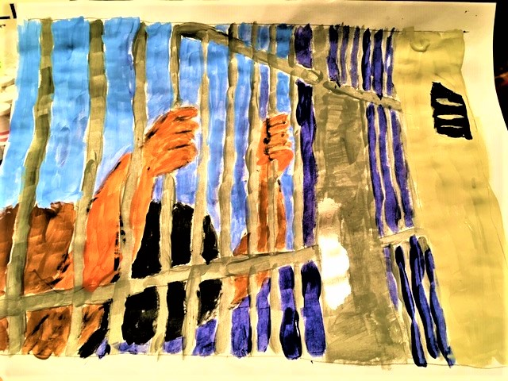

Dysfunction ruts are timeless Hells that groove
each move we make, for routine lines and lives
we know predict each new mistake. We prove
that we are ACA when fear deprives

us all, of peace and health and simple love,
due much to alcohol, this hellish drink,
that seems so bland, that needs a mindful shove,
thrown far away with all its train: that brink

that we’re free of. We’ve fallen down so man-
y times, we know now how to stand. We care
for us, and those like us, especially when
we’re banned. We’re on the outside looking where

we hope to sometime be: where we will see
our lives made whole, where we’ll soon be set free.

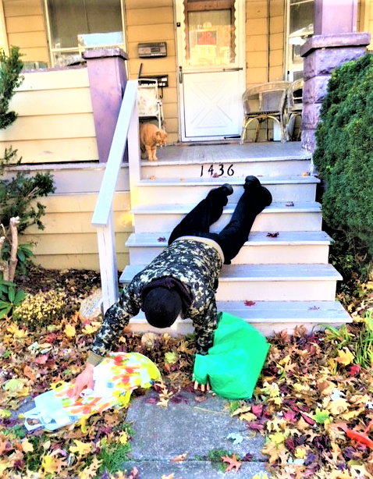

When balance is not symmetry, life spins
like wayward tops. It’s motion fills the emp-
ty void with chaos til it stops, begins
again reversing to undo pre-emp-

tive coils. Its logic is like day and night,
a back and forth of foils. Both up and down
are not the same, what’s low is not its height.
What steps are followed up the spine that crown

what’s out of sight? Life’s lessons are discov-
ered there, or not, while we are here. There are
no books or plans disclosing where God’s love
is near. All hope is based on faith and star

alignment chanced at birth, so future worth
is destiny that’s found down here on earth.

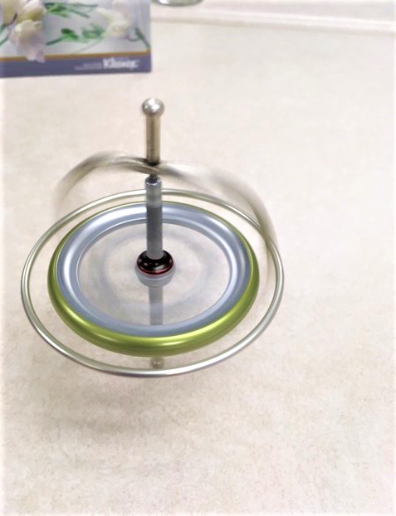

The party just got started here, the band
is tuning up. The decorations hung
with care, the booze is in my cup. I’ll hand
it to the organizers who’ve not rung

that bell, that warns all those attending this
we’re not too far from Hell. The circumstance
and pomp are such that all are lost in bliss.
The music and the dancing keep the trance

a rare abyss. The revelry is mar-
velous and features charm and glee. There’s no
describing tolerance for what’s this scar-
ring spree: that killing hidden means that slow-

ly topples all we love, and what’s above
and what’s below, without a slap of glove.

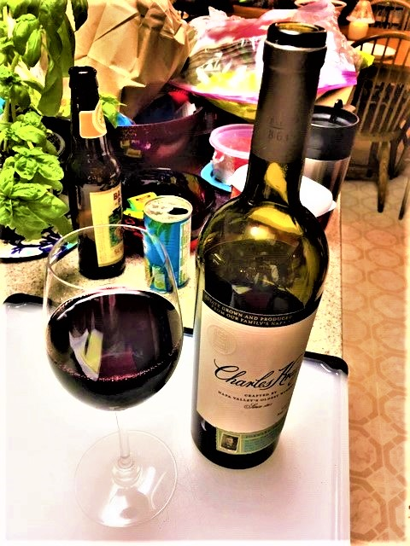
This labyrinth, that we call life, keeps chang-
ing as we move, with various direc-
tions, so each path’s an unknown groove. The range
of unexpected trials keeps correc-

tions lost. What faith we have, what faith we need,
makes reasoning the cost. Our inner eyes,
forever blind, just wonder how to lead,
when all we have within, without, seem lies

that foster greed. As parasites we choose
our hosts; we eat and breathe and take, these steps
to figure out our lives; I sure could use
a break. My efforts have all failed, like reps

that waste my precious time, so sweat and grime
and daily quests result in mindless crime.

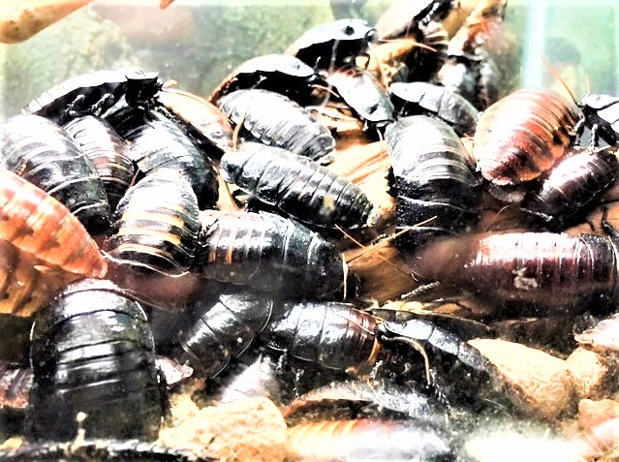

I spend my time looking for answers. It
is like seeking out water stations on
a marathon race. I’m peeking through shit
that does not end; the tedium’s not gone

away. What I’ve tried to do is of no
consequence to this day. My dreams are the
same. Survival I cannot ignore, though
my fears and longings trade places in a

waltz that’s pure show. I am not able to
detach my true inner self from the mess
of my past, my pains, my losses, all glue
and scum. I remain hidden, my address

is walking through life, stoned by features cloned,
as if my lame choices were somehow loaned.

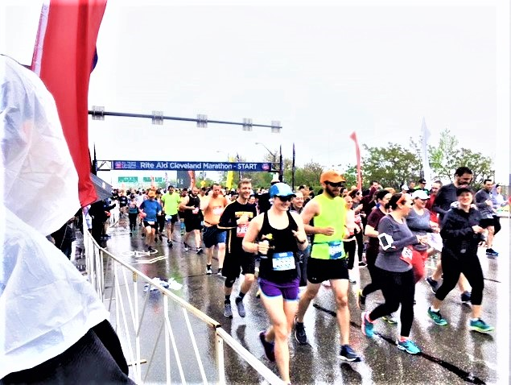

I never planned to plan, I said, the odds
are way too bleak. I’ve just discovered sen-
tient lies that play at hide and seek. What gods
insist that rules be clear? That closed eyes ten-

der counts? That gouls stay put in backyard games?
That nerf balls shouldn’t bounce? That cell phones keep
their secrets plain and seldom give up names?
That politicians smile less, and sleep

with fewer dames? That Marvel heroes are
not real? That mothers never drink? That God
is nothing if not love? That life’s a jar
of stink? That parasites on hosts aren’t odd?

That bullying’s not mean? That what’s obscene
in daily life is death that’s unforeseen?

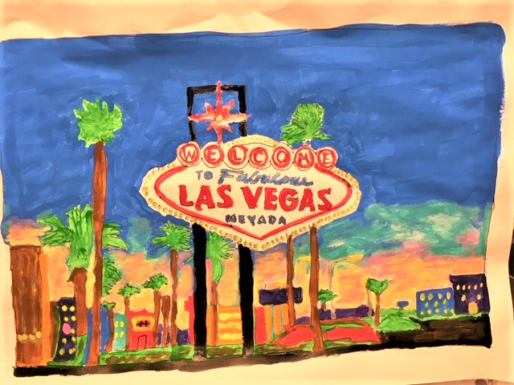

I’ve chronicled insanity, a page
ripped out of books. It all appears as won-
derful: by loving caring crooks. My rage
is often tantamount to light from sun

and moon, where shadows guide all relevance,
and sense is out of tune. I now believe
in Morpheus who placed pills on a fence:
one red, one blue, for what was true, to grieve

or soon commence, a journey down the hole
with Alice into wonderland, with eyes
wide open for the trip, awake for soul
command. The dead shall bury those compris-

ing shells marked vacancy, where in life’s sea
of plastic trash those down and out aren’t free.

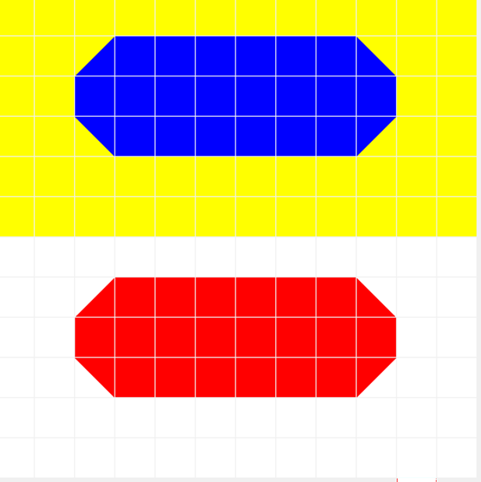

And no one’s asked me what I’ve thought about
what we all face, these dreams extending from
our eyes that light up all of space. What’s out
now in the open may seem weird to come

across, but let me share a secret here:
your space and time’s a cross; it’s what you’re nailed
to, while you dream, just ask your puppeteer.
He may supply some answers that are veiled

and quite unclear. I’d hoped to share a key
or two to unlock cuffs and chains, but maps
to show us where to go would never free
our brains, which are completely lost in naps,

and lullabied like stone, so we’re alone
in grave like trances caught in caves unknown.

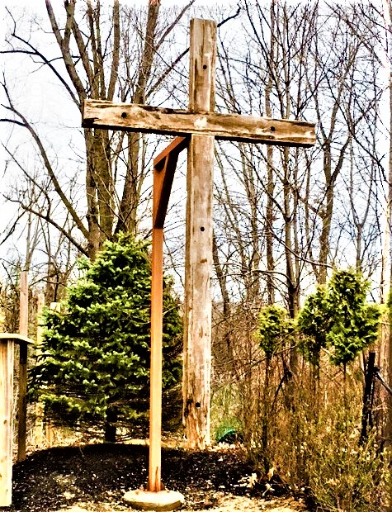

We March to different drummers here, the stars
determine this. We astrologically
control just nothing of life’s bliss. What mars
the comfort of our dreams and blankets rea-

soned hopes are flamed desires and attach-
ments blessed like binding ropes, that confound all
that we plan here and wreck each scheme we hatch,
as if we had a choice on Earth to call,

“Game, set, and match.” We have no say in an-
y script; our thoughts are rendered still. This game
was scored before we got here by God’s pen
and quill. The roles we actors must proclaim

and proudly preach and rant are but a scant
of nonsensed wind and what the gods implant.

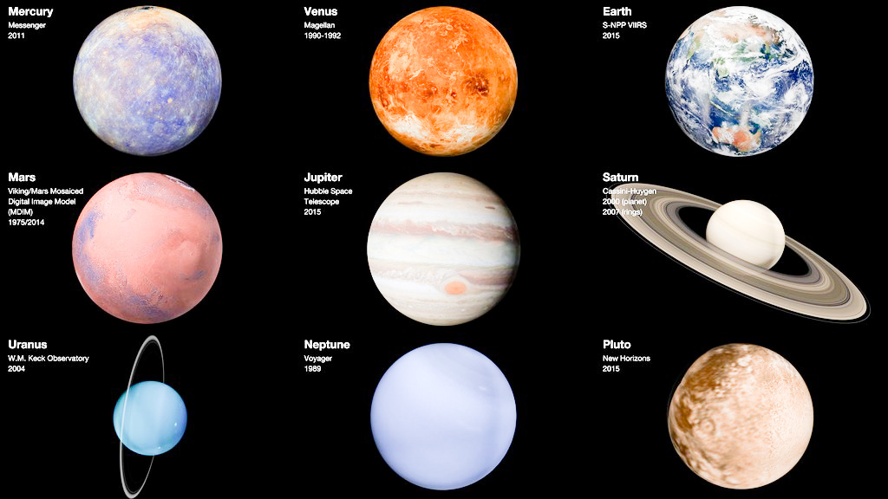

Few wins, that come with great defeats, are bless-
ings we could hold; though gauntlets that provide
rich pain confound such gifts with cold. To guess
at why we ever strive to dream, when hid-

ing’s safe, ignores all unsuspected thrills,
that charge events that strafe, and bomb, and cloud,
and wreck, and end good hope that fortune kills.
It’s balance that destroys all luck, so proud

of its famed skills. So bad with good, so left
with right, so up and down and wrong. You’d think
our karma would be fair, but fate’s so deft-
ly strong. It works its magic, makes you blink,

it holds your feet to fire. And though we tire
of rat race speed, we’ve failed to shed desire.

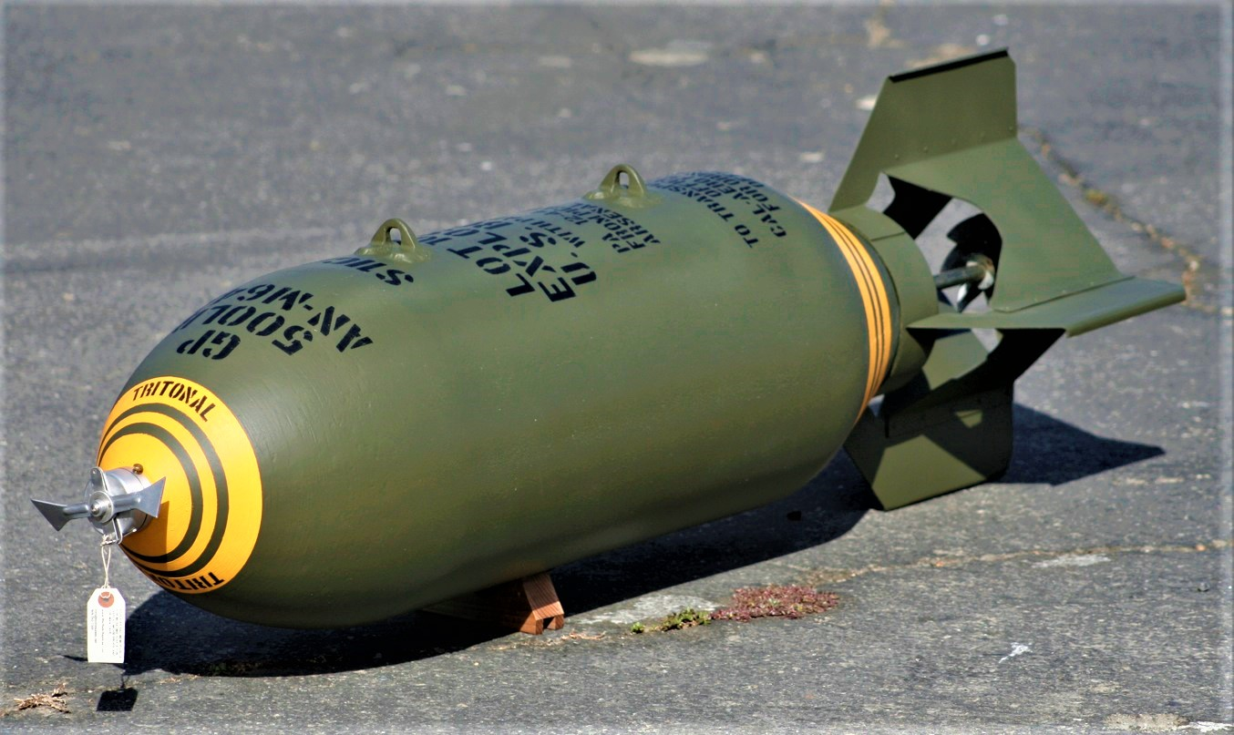

So all that we are going through was God’s
plan all along? The lyrics were all writ-
ten to this never ending song? The odds
that we might make it through this mindless grit

and noise, are up for grabs this wayward day,
who knows what Fate employs? There’s no discern-
ing what we’re dealt, no guarantees or say?
Who knows the “Truth?” Dare we believe, what learn-

ed scholars weigh? Who measures what author-
ities have given us to dread? Are we
to blindly follow, just like wars ignore
their dead, like witches of Macbeth, all three,

who spoke through hidden clues, and masked their views
on life and death, so none knew what to choose?

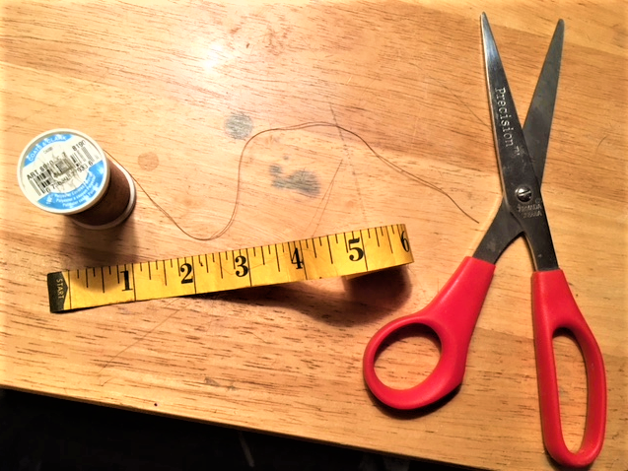

I don’t know where I fit in time and space
where God’s in charge. My path and work don’t seem
to fit this age where rifts are large. Earth’s pace
in this transition is too hectic teem-

ing shrill. This out-of-sorts condition blinds
attempts at sharing skill. Retreating far
from chaos sometimes helps releasing binds,
those clinging thoughts and feelings that can scar

unwitting minds. In plain sight I am hid-
ing. Is it wisdom, or just fear? I know
of nothing better, when I’m sure who’s guid-
ing here. I’ll wait in knowing patience go-

ing deep to peace inside, where what’s been tried
and true for souls will always be supplied.

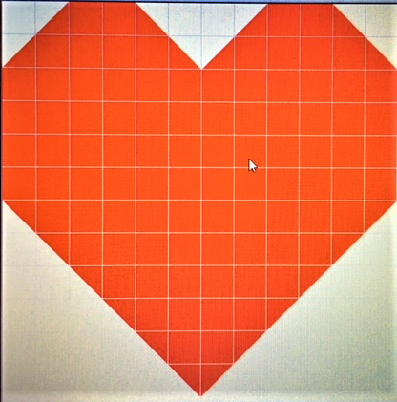

My noise of silence ringing loud sounds like
a snow plow blade, incessant grinding down
the street it’s like a game arcade, a strike
of bowling pins now echoed, or a clown

with horns. One’s silence should be peaceful not
a siren that forewarns. To meditate
alone at dawn should start with thoughts forgot,
with chanting peaceful mantras that relate

to third eye dot. The beingness of be-
ing needs to blossom where it is, without
obsessions or desires: Eden’s tree
and quiz. Discovery is hereabout,

and now forevermore. But what a chore
of effort to go far within Heart’s door.

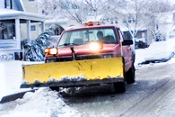

The mountain that conceals our God recedes
when fools approach. Their darkness is a mas-
terpiece: one God need never coach. He leads
His chosen few along a blessed pass

through Hell, while what’s amassed humanity
stays caught in Satan’s spell. God’s scripted play,
that’s set in stone, and promises to free,
all those within His mighty grasp, who stray

from how to be, is fraught with thought that works
all minds, and busies every deed, and keeps
all action going strong; it rightly perks
all need. Its motion grinds and never sleeps:

that blind all-seeing eye, that weighs each cry
and mournful tear, while time goes marching by.

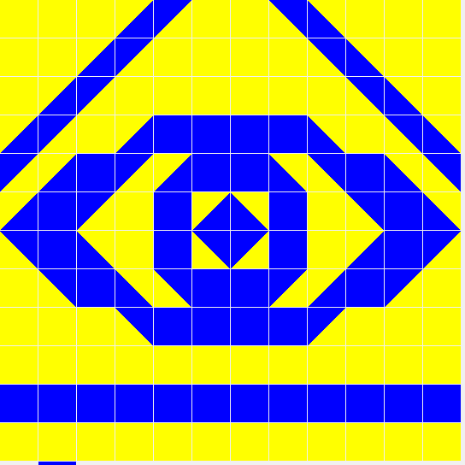

The chill of springtime’s in the air, the breeze
is silent loud. The faceless strangers out
for walks are seamless as a crowd. The trees
stay helpless as they bud, not caring ‘bout

leaf’s shade, but welcome sunshine, clouds, and rains.
These wonders all have stayed. Of course direc-
tion’s seasonal for migratory cranes,
where ducks and warblers northern bound, all trek

a patterned chain, evolved through countless years
or more, like clockwork’s silent chimes. And clouds
drift by so noiselessly, and make our tears
seem crimes, just begging for those faceless crowds

to stop and please be still, to stand the thrill
of springtime joys, and cease time’s marching drill.

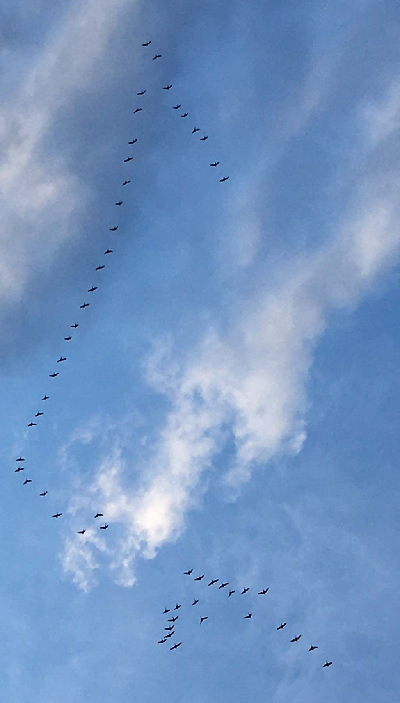
The peaceful slaughter of the slaughtered peace-
ful is the new balance in time’s clock, way
too cosy for sunsets and blue skies, cease-
less seasons of wanton happiness, play-

ful days: those mindless rhythms and bastions
of griefless journeys, ways for staunching sane,
when all the world’s smiling at Earth’s actions,
as if the reverie and joyful pain

of love’s factions, dancing heedless through end-
less masquerade balls, where lost glass slippers
are all the rage, were just the way to mend,
alas, a few lost hopes, those failed grippers

to reality’s ledge, that lovely edge,
where, through Time’s joy, “Just what’s behind God’s hedge?”

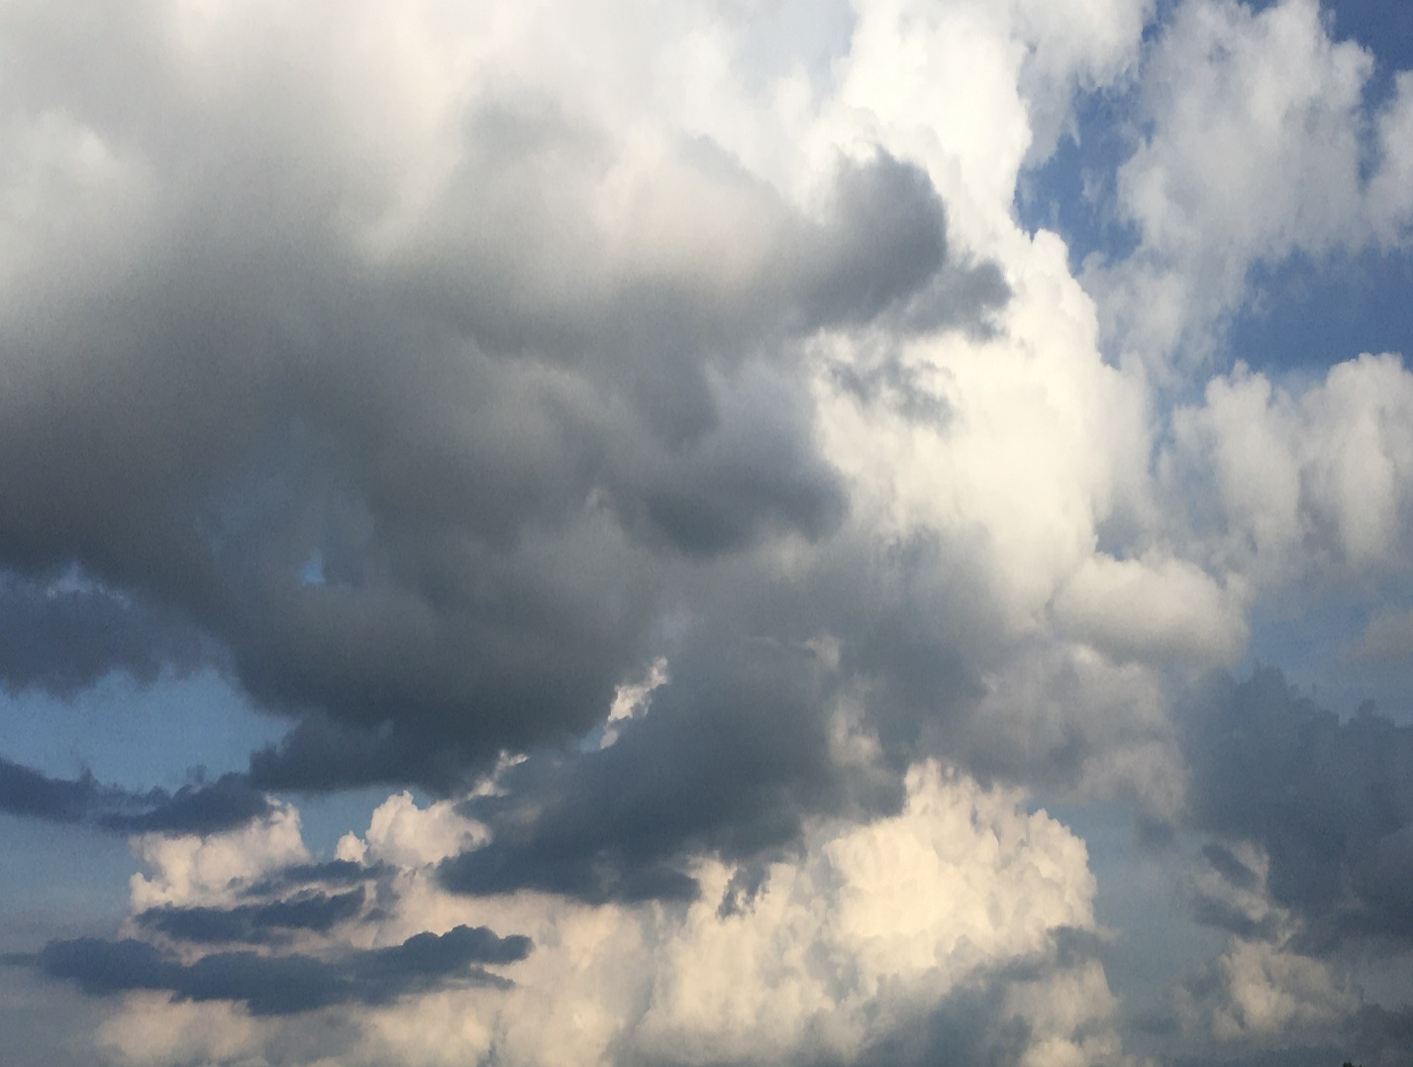

Belief and hope and faith, oh my, what will
sustain us now? These yellow bricks are stained
with loss, and we all wonder how. And still
we trudge on aimlessly, down here, contained,

confused; we strive to understand our plight;
but no-one here’s amused. What have we here,
what have we done, with no clear end in sight?
It seems we’ve not been given truths that clear

this endless night. So hopeless, faithless, try-
ing hard, we seek what doesn’t sting. Yet all
that we encounter tells us, “You’re what dy-
ings bring. You never will escape your fall;

you can’t escape God’s pen.” We mice and men,
are surely blessed; we’re screwed here once again.

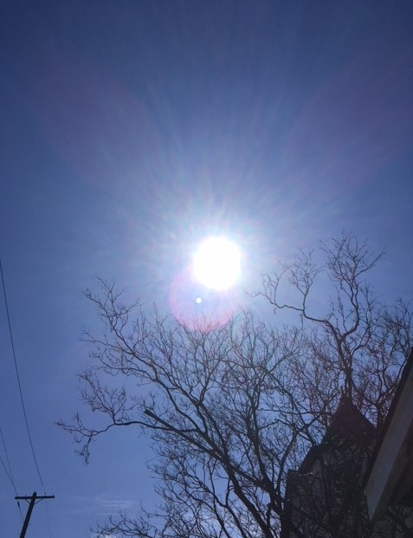
Lost time, lost will, lost purpose here, life’s stage
gets cleared of acts. The scripts get dumped and burned
as trash; our history’s not facts. This age
was orchestrated by some gods who turned

this tale. Agenda that they keep in si-
lence are designed to fail. We’re pieces on
a moving chess board that upholds a lie,
a destined plight and controversial con

that’s do and die. Lord Bacon knew a thing
or two about this blessed Earth. His son-
net numbered 1-2-9 blows up death’s sting-
ing birth: where we’ve come from, this ride we’re on,

that leads to stress and pain, where all the gain
we’d hoped to steal, swirls slowly down death’s drain.

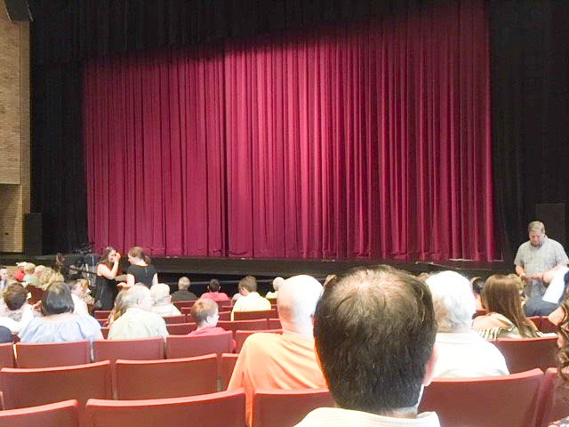

Predictions of our worth are dumb, for God
controls our strings. His moods forever change,
like truths and faiths and storms in springs. What’s odd
is that our puppeteer is fickle, strange,

and weird. His love is like a bowling ball,
and we’re the pins He’s feared. We misinter-
pret why we’re here, all based on Adam’s fall.
We never were in Heaven’s grace: deter-

mined like a wall. We’re props in His divine
stage play, His endless, mindless fit, just pre-
disposed as after thoughts, like tasted wine
that’s spit. We’ve never known our destiny,

we’ve just believed His lies, His frail disguise
of love and peace, when what’s here’s Hell’s surprise.

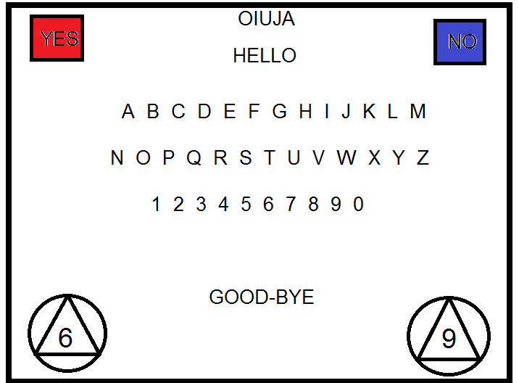

“The best laid plans of mice and men” have skipped
a ripped out page, a missing tract that’s lost,
it seems, from what now spans an age. The script
it had a footnote warning all the cost

of time: that efforts to create a hit
are melded with a crime: the flip side of
a coin that’s forged, Hell’s Yang, plus Yin, unfit:
a dose of hate that’s built into a love

that will not quit. So “Welcome All, who wan-
der here, just mind your stepping stone. It can
be slippery for sure, especially on
your phone: it’s made distractions blessed more than

a million little kids, and what forbids
your learning: while all life is on the skids.”

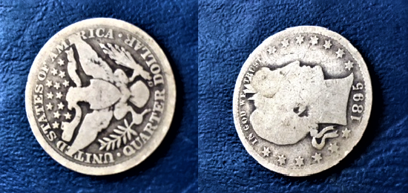

Titanic’s now our planet Earth; we’ve no
lifeboats to row; and no star ships to res-
cue us; we’ve nowhere else to go. This show
will have no curtain call, and now Time says

it’s true: our end is just reality;
this final stop’s what’s new. We’ll hand it o-
ver to some bugs, our mantle, now we’re free.
The cockroach or the mealy worm, now low,

will be marquee. This run it’s been so won-
derful, you’d think there would be more. To end
with caskets lining fields is not a mon-
eyed score. But we’re just actors that pretend

that life here’s worth a lot. But we forgot
that fine print of the contract stating, “Nought.”

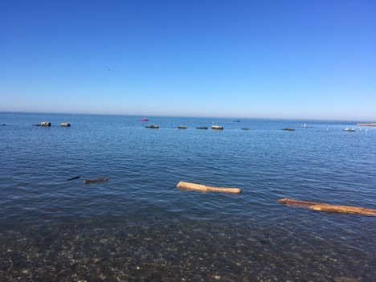

I sit here waiting for my God to show
me all His Plans. The stillness and the si-
lence are now laughing at demands. I know
my time means nothing in the scheme of why

I’m here. I’m scared, content, but wondering
if it’s my place to steer. Am I co pi-
lot or a passenger now blundering?
What place have I? What role is mine? And why

life’s thundering? Is this the valley of
the shadow that I walk alone? What place
is set before me here where I can’t love
what’s known? But what is known, all that I chase,

when silence overwhelms, when God, whose helms
are love and peace, has left all earthly realms?

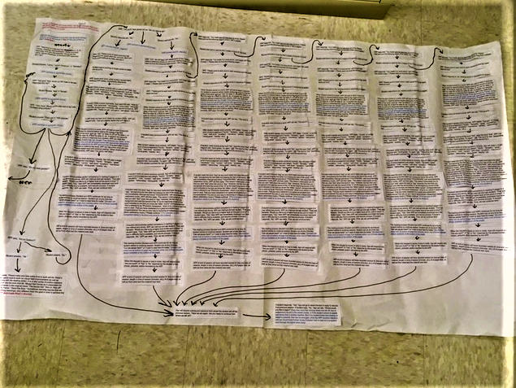

Destruction is instruction, can’t you see
God’s holy plan? Your learning is discern-
ing what’s a fire from a pan. The key
to understanding is demanding earn-

ing’s cash. This world’s been hurled to nether’s pits,
so all here need a stash; though rush
to hush all claimants is the fix that Hell permits.
What feeds all needs is hope that’s blind, the crush

of neoned glitz. The cure for sure was nev-
er here; we’re deep in Heaven’s stew. The Mind
behind this playground mess depends on sev-
ered you, just diced and sliced here to remind

that your life’s not worth squat. God’s plot was not
to set you free; that never was His thought.

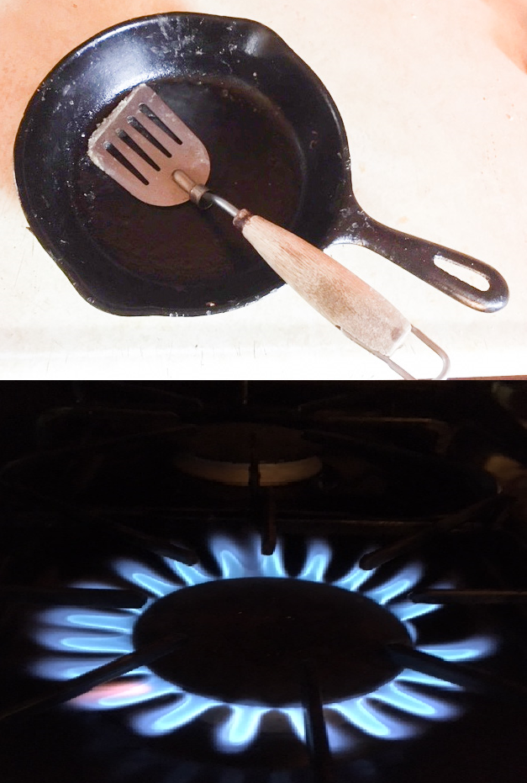
“How many lies must we believe to fill
our empty souls, to rearrange our worth-
less lives, and gladly seek God’s goals? This pill,
this shot, this remedy: now what on earth

are these?” “Please take them all, you must agree;
this governmental squeeze, is necessar-
y for your future, keeping us all free.
There can be no mistake with this, your care

just costs a fee, a teeny tiny sac-
rifice, it’s worth the health you risk. You might
not see it all right now, but why attack
what’s brisk? These mandates now assure what’s right,

but please move fast in line; you are not swine
or sheep or beef; we’re sure the jab’s benign.”

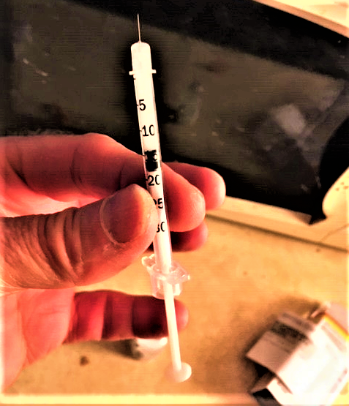

The cosmic wheels that slowly turn and lev-
el all that is, keep mindless jerks like you
and me astounded at life’s quiz. They nev-
er fail to undo dreams and squander foo-

lish works, and all that mankind undergoes.
They seldom offer perks. And God is not
responsible; the Devil runs Earth’s shows.
But who or what now pulls his strings? That plot

God won’t disclose. Life’s answers to all ques-
tions are like rainbow pots of gold, that make
all searching pointless; it’s like myths that les-
sons hold? We’re thieves who trespass Earth’s mistake

and wander aimlessly, devoid of free-
dom, sense, and skill, like nuts beneath God’s tree.

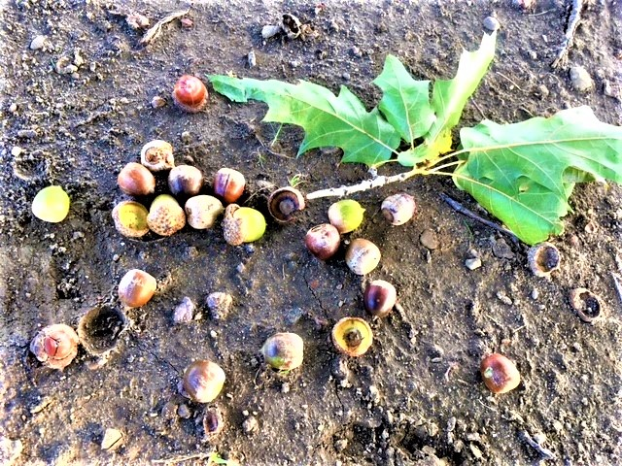

Duplicitous is God, we see, to make
this earthly mess. He’s still in charge of all
this Hell that’s plagued with righteous stress. Mistak-
en, what we’re told was care, that blessed our fall

from grace, will never change realities
which we’ll forever face. What’s said, then done,
does not match up, it’s like this dread disease,
where fears and pains and cures for health are spun

through lies with ease. Whom we believe, who’ll save
us all, when chaos brings on death, are fiends
in woolen clothing who will praise our grave
yard breath. They are God’s chosen, and his means,

to fool us once again; forever then,
we’ll pace this cage as convicts in life’s pen.

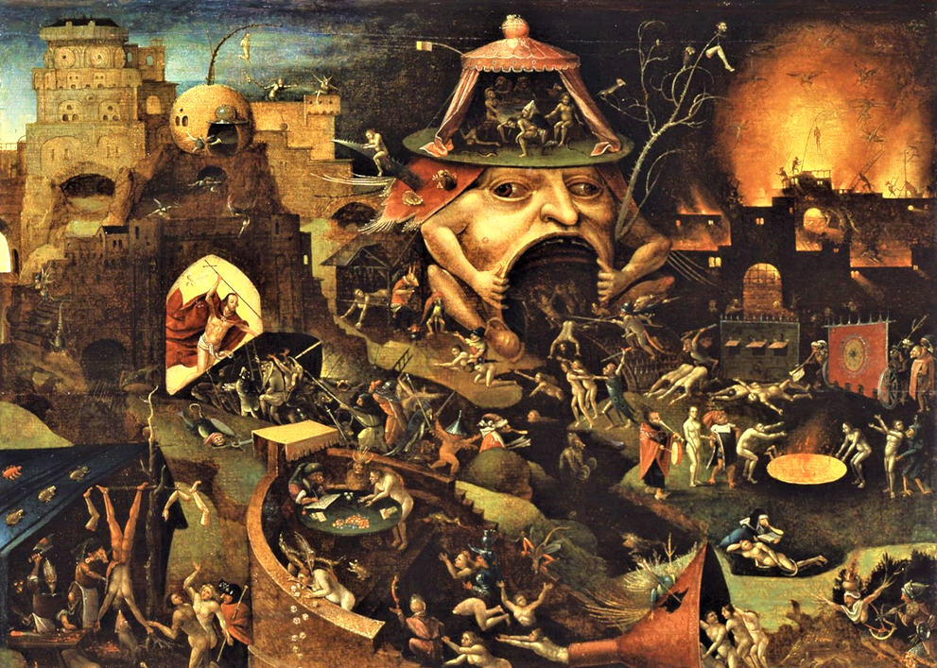
Christ In Limbo by Hieronymus Bosch, 1575

Predestination is the maze that gov-
erns how we move. The myth of free will begs
that we’ve got nothing left to prove. I love
the brave insanity that praises dregs

as life, and thinks we are in full control
of money, health, and strife. What prayers are wel-
comed, blessed, and shared, and help each wayward soul?
Forgiveness keeps us heaven bound, and Hell

can’t sway whose whole. Myopic views that know
all truths, and limit what we see, are ill-
prepared to understand rare thought that’s so
not free. This world demands we praise each pill

that’s passed to those afraid. So every grade
we’re handed here just shows us we’ve been played.

God grant me the serenity To accept the things I cannot change; the Courage to change the things I can; And the wisdom to know the difference.

Thank God for this pandemic here, this might
of wordy lies, we have not suffered long
enough beneath this masked disguise. This night
of terror has it all, a plague so wrong

it’s weird, the propaganda perfect so
all know it’s to be feared. Intelligence
now cast aside, with wisdom on the go,
there’s nothing left to harbor thought or sense

down here below. We’re lost in Hell’s great swamp
of fiends, those heartless sordid beasts. We’re right
here to be skinned, prepared, as food at chomp-
ing feasts. The gods have got an appetite,

so revel in your fate, it’s not too late
to change your course, just choose which bowl or plate.

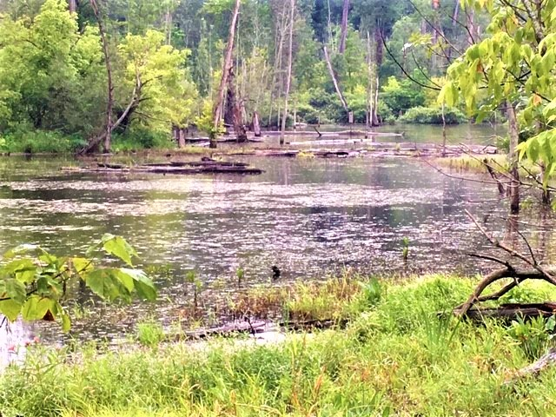

We live in monstrous fantasy; this world
is but a game. There are no rules, there are
no goals. We’re prisoners in this shame. What’s hurled
at us down here on Earth will keep us far

from home. In every venue we subsist,
no benefits from Om. This prison here
has much to love, such choices we could list,
much more than we could ever manage, clear-

ly truth’s been missed. It hurts that we’re all stuck
here in an endless cycled loop. It may
be that we’re comfortable with all this muck
and poop, like barnyard flies who fight and play

for bigger fresher piles, as if these trials
were blessed and fine and just like birthday smiles.

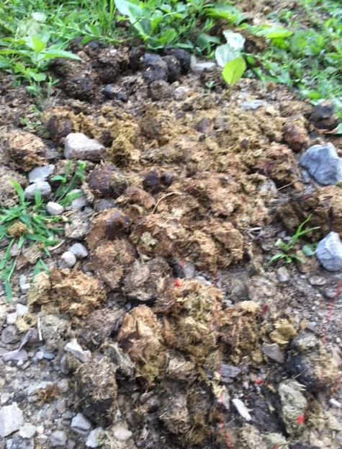
Samadhi is my goal today, my mind
wants to resist. There are no steps that I
must take, my realization’s missed. I find
that peace is with me now, I will not try

or do; all effort that is effortless
is what will see me through. My mind can’t share
in peace or love, it only knows distress,
and wandering through fantasy, while car-

ing for life’s mess. I think I’m done with all
the waste, what’s unreal and what’s loss. I miss
God’s love, the Om that’s home, above my fall-
en cross, that active/passive noose on bliss

that drags my earthly frame. But now my name
is here in Being, all beyond life’s game.

